**Create a set of online banner ads with 3 slides.**

SIZES REQUIRED:

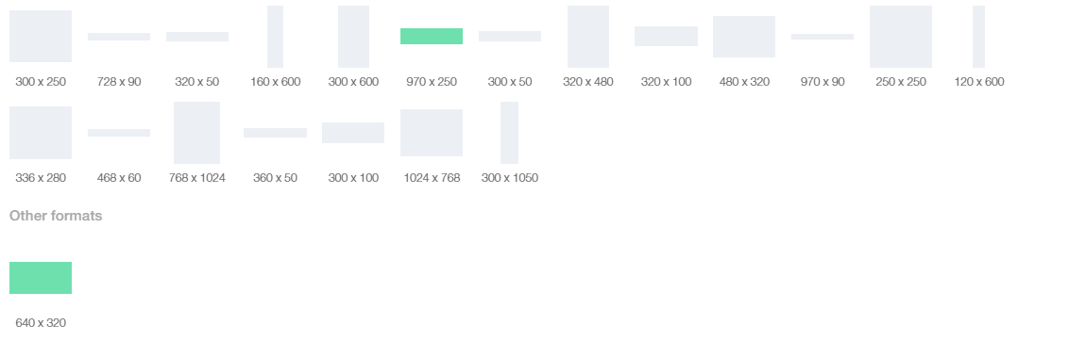

**The 3 slides content should include:**

**Slide 1 text:**

Christmas Accommodation For The Entire Family In Nelson Tasman

Available 23-28 December

Include pear lodge logo

Include Book Now and link to go to [Booking Process - Bookable (seekom.com)](https://book.seekom.com/front-booking/book/thepearo17/2066?sellerEntity=account&roomByIds=37576,37578,37577,37676,41061,37579,37747,52828,52829)

**Slide 2 text:**

* 7 Bedrooms
* Modern Kitchen
* Large Dining
* BBQ
* Great Garden Area

Include pear lodge logo

Include Book Now and link to go to [Booking Process - Bookable (seekom.com)](https://book.seekom.com/front-booking/book/thepearo17/2066?sellerEntity=account&roomByIds=37576,37578,37577,37676,41061,37579,37747,52828,52829)

**Slide 3 Text:**

$999/night  
Up to 16 people  
($63/night per person)

Minimum 5 nights stay

Create Memories This Christmas

Include pear lodge logo

Include Book Now and link to go to [Booking Process - Bookable (seekom.com)](https://book.seekom.com/front-booking/book/thepearo17/2066?sellerEntity=account&roomByIds=37576,37578,37577,37676,41061,37579,37747,52828,52829)

**Colouring**

Use Red, Green (for Christmas) and white

**Images:**

Dropbox link

<https://www.dropbox.com/sh/iz2u6yptnm0dlm2/AACmBX-alJ60HfHCY0K_rWc4a?dl=0>